About Us
Eden India Pvt. Ltd. is a Punjab based company that has been providing services in real estate, cosmetic, electrical and electronic goods etc. for unpredictable tastes. We are a young firm with a team of professionals who share a passion for the best & therefore are constantly working to provide modern, practical &solutions that suit your requirements.

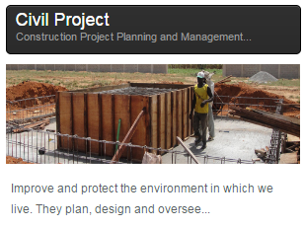
Services

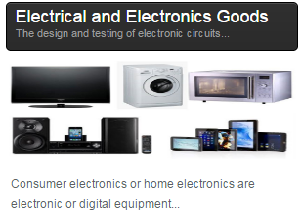

Job Description
Current Requirement :-
Company Name | Eden India Pvt. Ltd.
Salary | 10-15k
Industry Type | Survey,Telecom,Installation
Designation | GET/DET
Eligibility | B.tech /Diploma Civil,EE,ECE
Location  Date of Campus | PAN India  18-04-2017

Candidate Profile: -
- Team Management & Coordination.
- Implement things according to design.
- Responsibility of designs etc.
- Assign work to labor & semiskilled workers.
- Responsibility of assign site.
SELECTION PROSSES:-
- GD ROUND
- TECHNICAL ROUND
- HR ROUND
OFFER LETTER ON SAME DAY
Regards
Team HR
Eden India Pvt. Ltd.

